**Next Generation EU funded project**

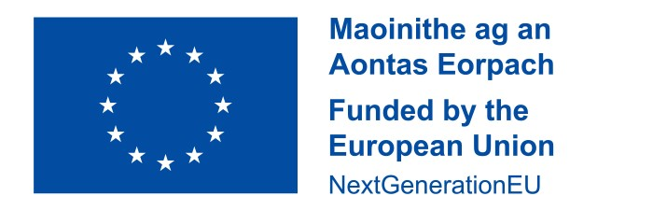

This school received a grant in 2021 to implement initiatives aimed at addressing the digital divide and support our learners at risk of educational disadvantage as a consequence, as part of the Irish National Recovery and Resilience Plan (NRRP) a project under the Recovery and Resilience Facility funded by the European Union through NextGenerationEU. This funding was used to purchase Computing devices, local software, 'apps', and online resources, to support learning. (These are some of the examples that have been used to date as per the criteria outlined in circular 0060/2021).